Supporting Information for

**Wetting Characteristics of Nanosilica-Poly (acrylic acid) Trans-parent Anti-fog Coatings**

Sevil Turkoglu1, Jinde Zhang1, Hanna Dodiuk2, Samuel Kenig2, Jo Ann Ratto3,Joey Mead1*

1 Department of Plastics Engineering and Center for High-rate Nanomanufacturing, University of Massachusetts Lowell 40 University Avenue Lowell, MA 01854

2 Department of Plastics Engineering, Shenkar College, Anne Frank St 12, Ramat Gan, İsrail

3 US Army Natick Soldier Research, Development and Engineering Center General Greene Avenue, Natick, MA 01760

*Corresponding author, [Joey_Mead@uml.edu](mailto:Joey_Mead@uml.edu)

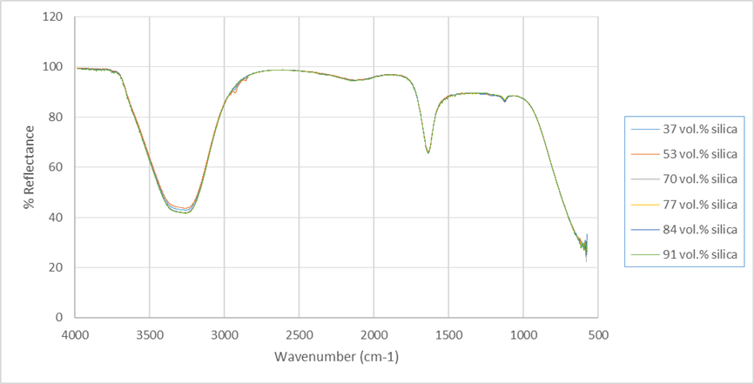

Figure S1. FTIR spectrum of several samples

Figure S2. SEM cross section images of coatings with particle loading (vol. %) of a) 37, b) 53, c) 70, d) 77, e) 84, f) 91

Table S1. Coating thickness values

|  |  |  |  |  |  |  |
| --- | --- | --- | --- | --- | --- | --- |
| **Particle loading (% vol.)** | **37** | **53** | **70** | **77** | **84** | **91** |
| **Coating Thickness (μm)** | 8.34±0.7 | 5.07±0.9 | 3.01±0.6 | 0.94±0.3 | 0.80±0.4 | 0.50±0.3 |

Figure S3. Size distribution curves

Figure S4. Correlation function vs delay time

Table S2. FTIR peak assignments

|  |  |
| --- | --- |
| **Wavenumber (** | **Tentative assignment of functional group** |
| 3255 | OH stretching and hydrogen bonding |
| 1074 | Si–O–Si stretching |
| 767 | Si–O bending |
| 1635 | C=O stretching |
| 1122 | C-O stretching vibrations |
| 2135 | CO2 |
| 1555 | C=C stretching |
| 900 | C=C bending |
| 821 | C-H bending |

Figure S5. Optical microscopy images of coatings with particle loading (vol. %) of a) 37, b) 53, c) 70, d) 77, e) 84, f) 91 before (left) and after (right) adhesion test